

**Project Name: Family Tree**

**Objective: To Store and Relate Same Family Stories**

**Course Code: CSE323**

**Instructor - Dr. Nova Ahmed**

**Group Members:**

1. **Sharif Ahamed, ID-1510656042**
2. **Jabid Hasan Pappu, ID- 1511885042**
3. **Md. Mahmudul Haque, ID- 1511944642**
4. **Sayef Sarkar Eashan, ID- 1513253042**

**Project Name and Objective:**

Our project name is Family Tree where our main purpose is to store and relate a single family stories and make it available to everyone of that specific clan.

**List of APIs:**

1. Google Text To Speech:

Here, we planned to use google text to speech for reading out the story.

1. Google Search API - Search Manager:

In this API, we search the family members’ stories by using tags, places, time, actors. Through this we can relate stories.

1. Google Places API.

**System Diagram:**

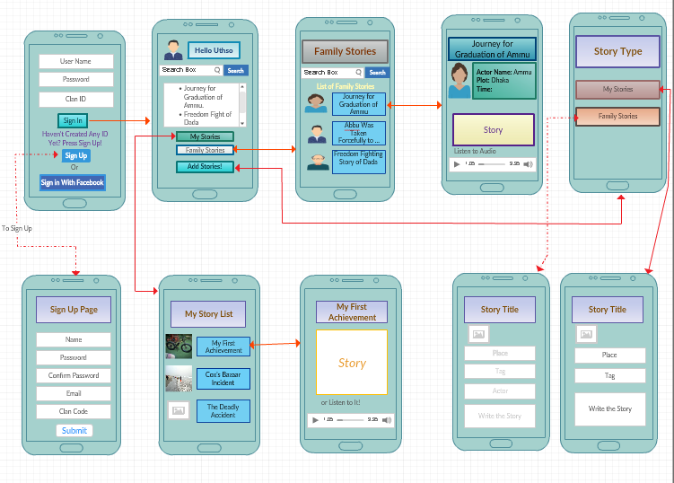

**Code Sample:**

Story View**:**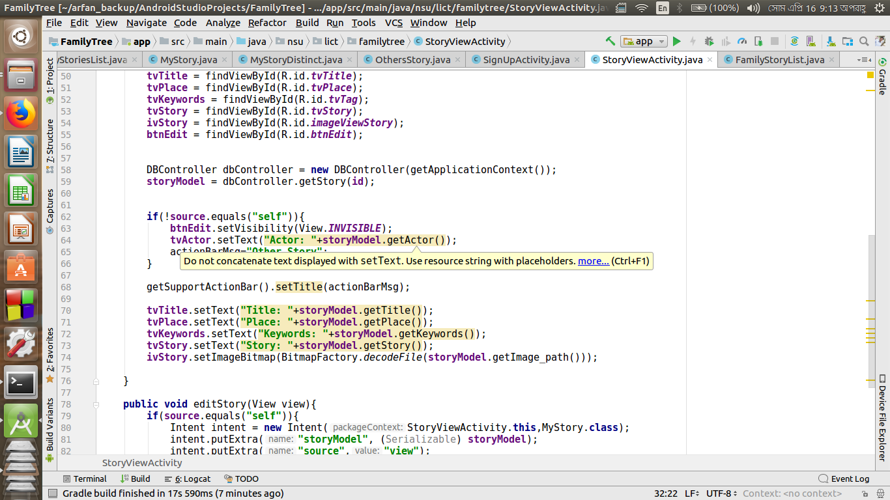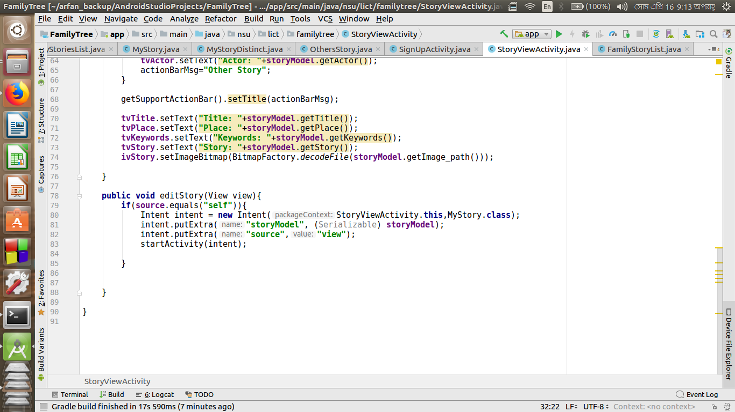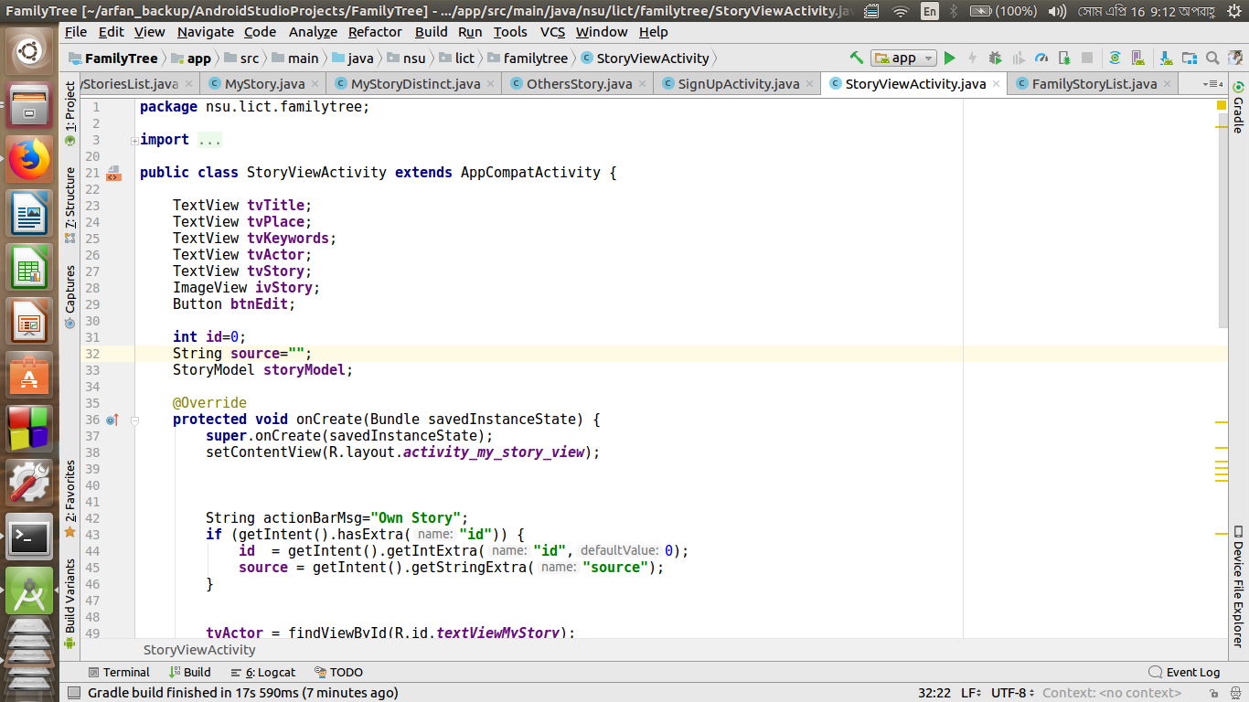

**Database Controller:**

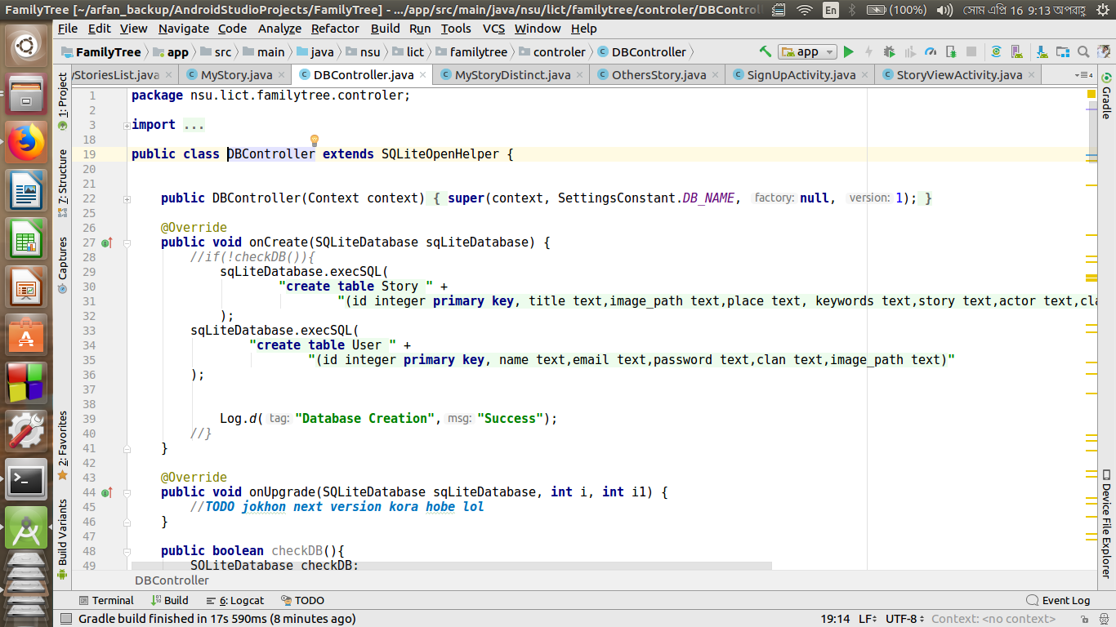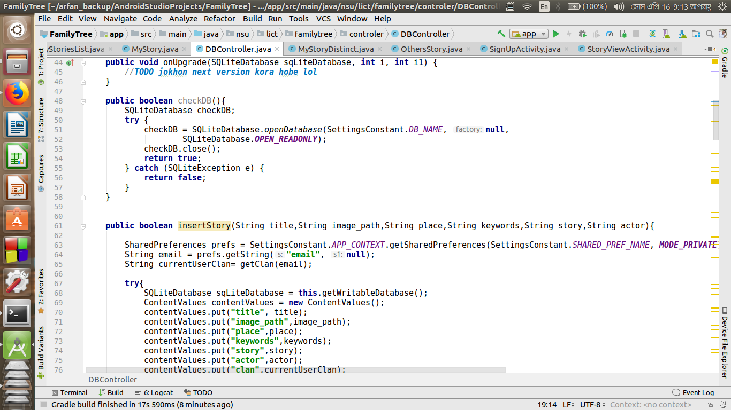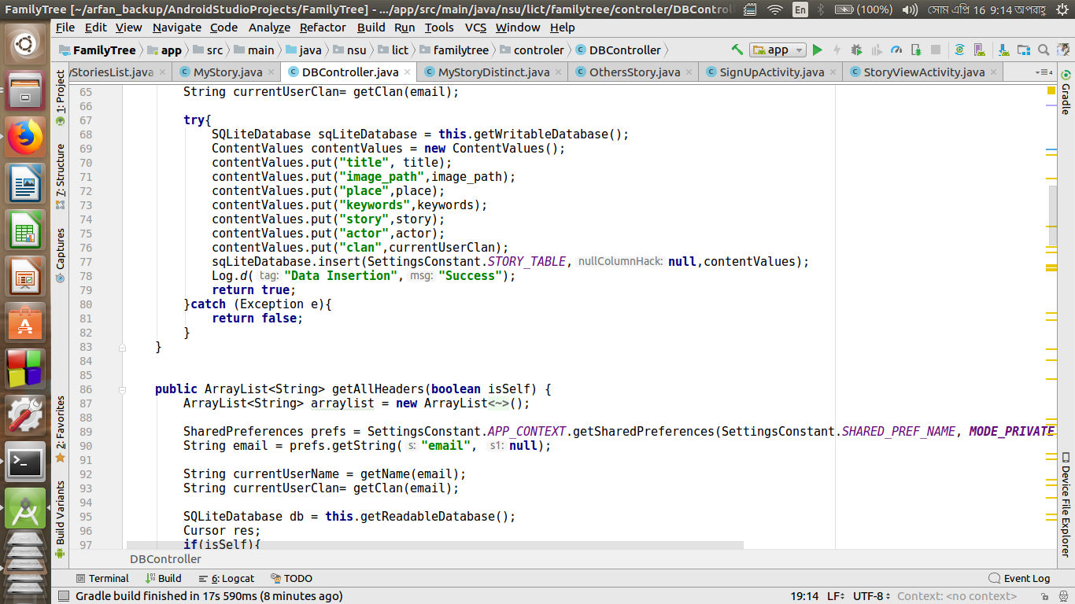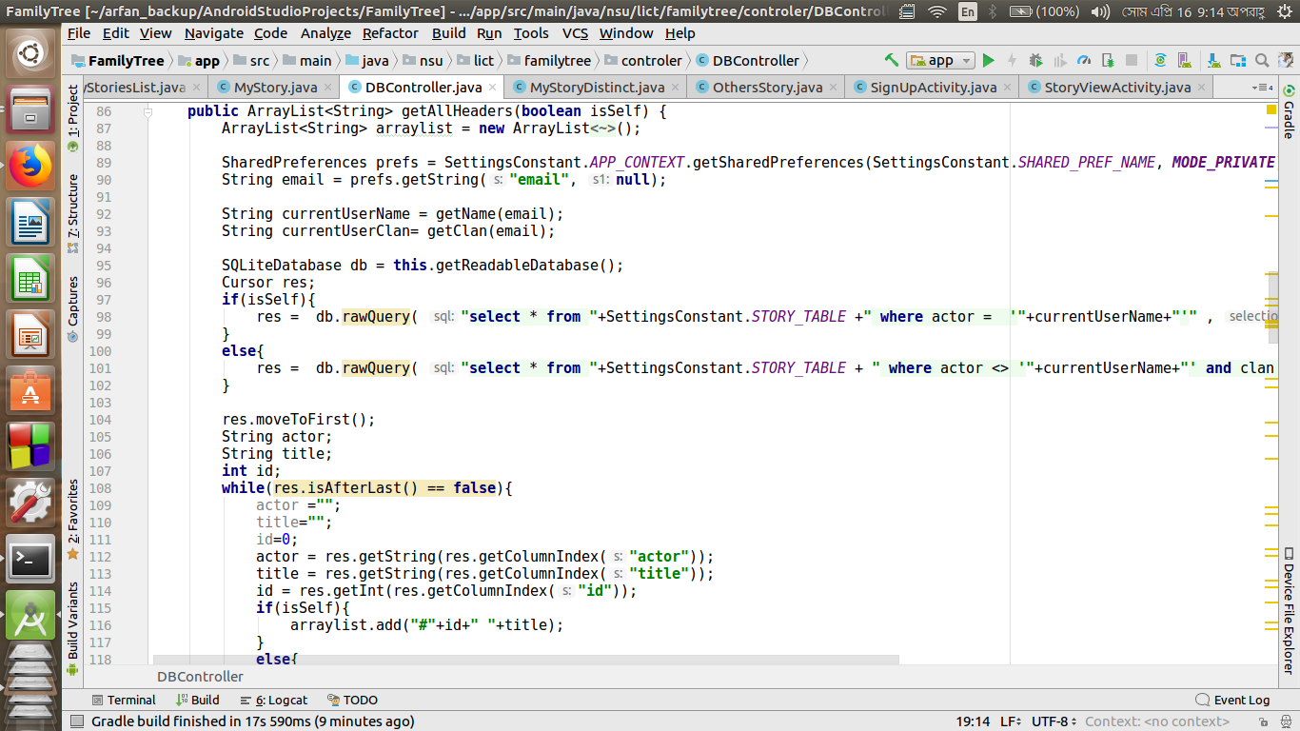

Story Classes:

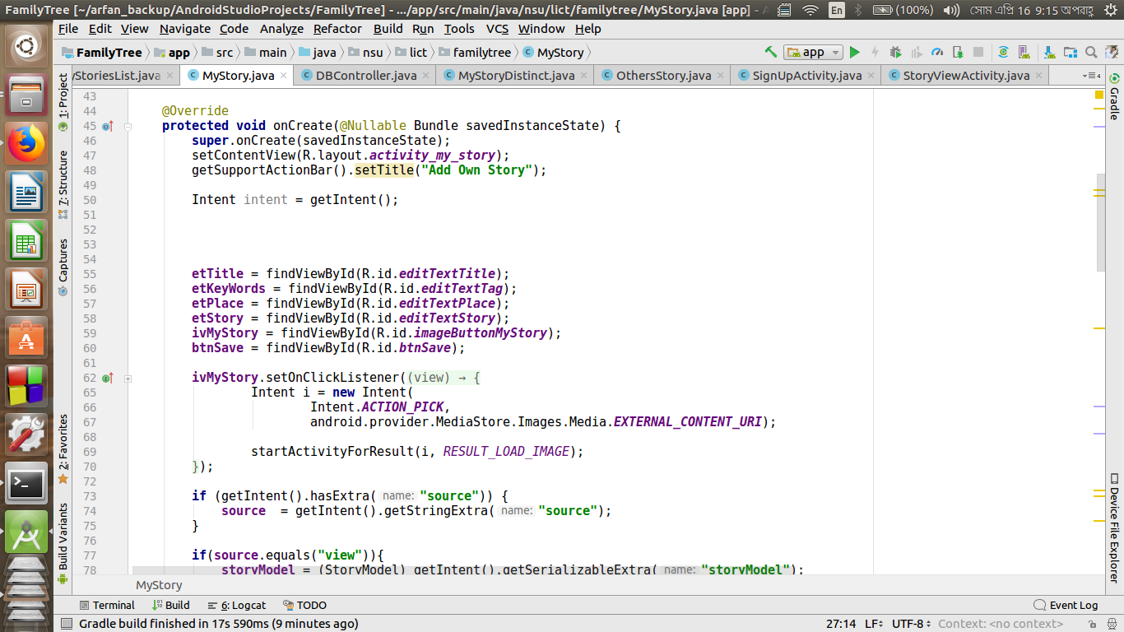

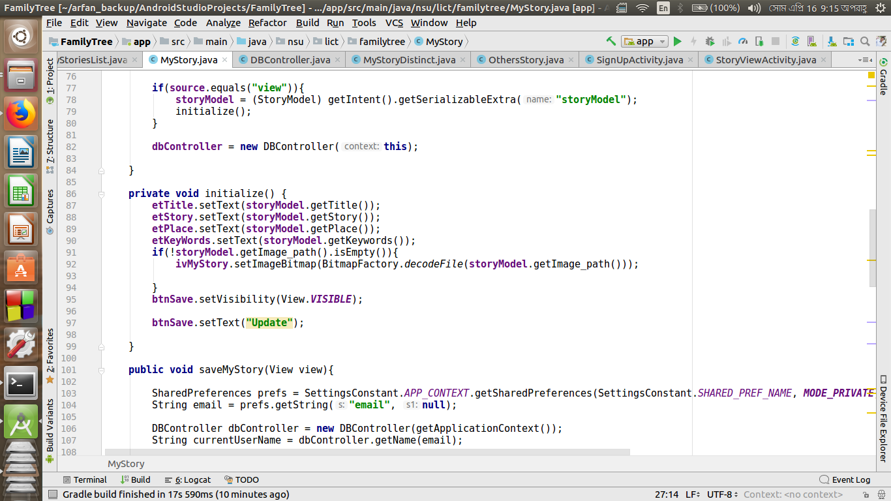

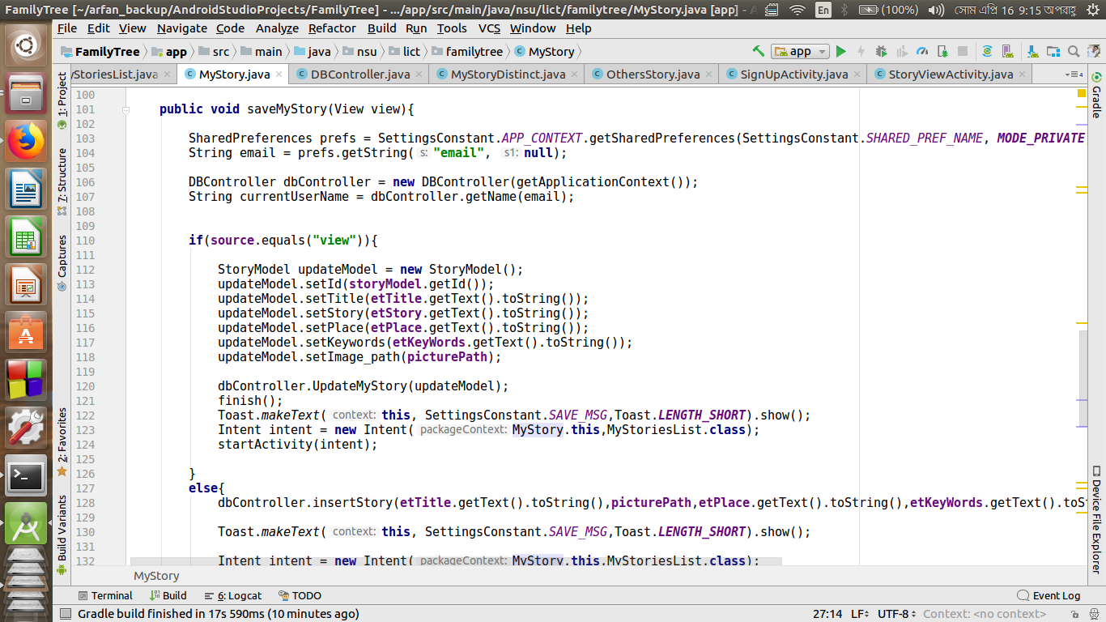

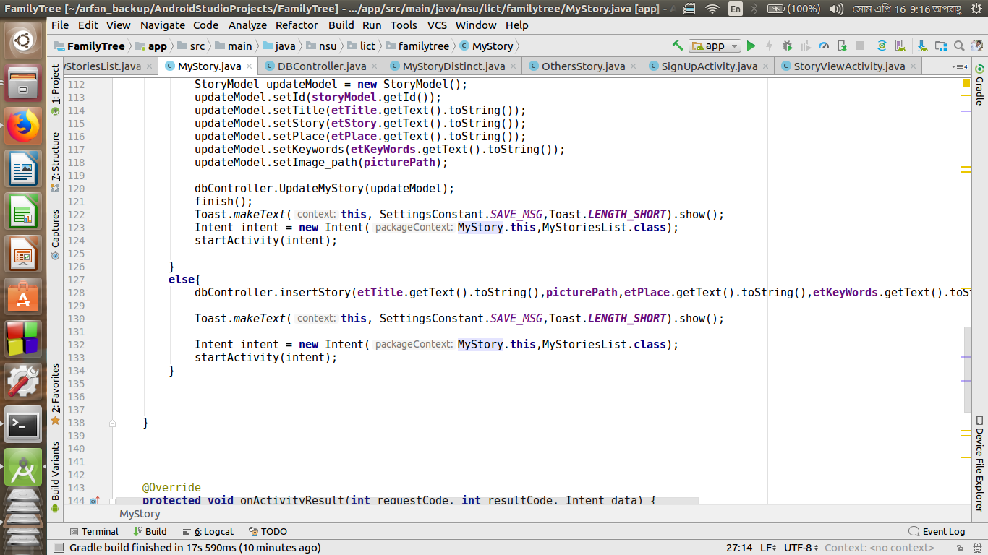

**What Went Wrong!:**

* We tried to relate stories by tags but unfortunately we could not do it properly. Still our application can search by some tags.
* We tried to use voice input. But the API we were trying to use for voice input was not built for longer speech. So, we had to avoid it.
* Still we are not availing the edit option for my stories as we have to maintain a lot of data to store it. Also we have to reconfigure the search options if the edit option is available.
* We tried to read out the story using Google Text To Speech API. But for long stories they do not work properly.

**The Lesson We Got From It:**

* How to re-calibrate Google Search API- Search Manager and use it for our own relate purpose.
* For privacy we had to maintain a Clan Identity where we used it as a unique identity for every clan. That is how we had to learn how should we give the identity to maintain it smoothly.
* Overall we learned the team working procedure which really helped us.